**The names of all the countries in the databases which start with the letter "B" (sorted by their names)**

*select distinct country from sakila.country where country like "B%" order by country;*

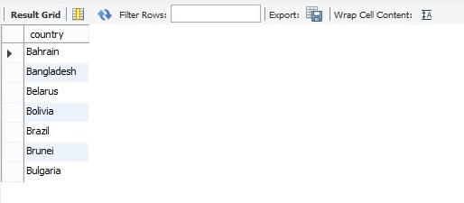

**Return the first names (sorted) of all the actors with the last name "berry".**

*select distinct first_name,last_name*

*from sakila.actor*

*where last_name like "berry%"*

*order by first_name;*

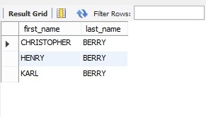

**The films whose length is more than 184 (inclusive). Order the results by the length (and for films with the same length order them by their name). Return their title and the length.**

*select title,length from sakila.film*

*where length>=184*

*order by length,title;*

